***AMSAT***



2

**RadFxSat-2 Venting Analysis Report**

## Document Change Log

|  |  |  |  |
| --- | --- | --- | --- |
| **Revision** | **Date** | **Author** | **Change Log** |
| 1 | May 13, 2018 | R Davis | Initial write |
| 2 | July 2, 2018 | R Davis | Updated for boards. |

## Satellite Team Responsible Engineer

|  |  |
| --- | --- |
| **Author** | **Contact** |
| R Davis | KF4KSS@AMSAT.org |

**Purpose:** The purpose of this document is to provide the venting analysis of the RadFxSat-2 CubeSat as required by MRR of NASA VCLS ELaNa XX.

1. **Vented Volumes:**

L1-VCLS-ICD

Each CubeSat will show analytical evidence that the that the CubeSat can survive the payload fairing venting rate of ≤ 0.4 psi/sec (dP/dt).

LSP-REQ-317.01B § 6.2.13

CubeSats shall be designed to accommodate ascent venting per Ventable Volume/Area < 2000 inches in accordance with accepted standards such as JPL D-26086, *Revision D, Environmental Requirements Document (ERD)*.

1. **Unvented Volumes:**

All volumes in Fox-1C are vented.

1. **Venting Locations:**

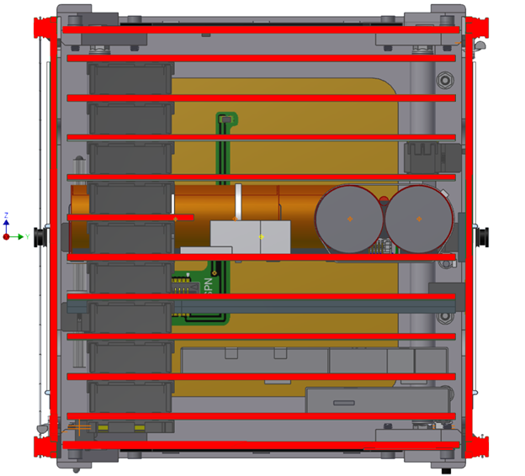

LEP

Spacers

Spacers

RX/TX

ICR

IHU

Battery

MPPT

REM

LEPF

VUC

Figure 1 Cross-section From +X, showing PCB Stack

Figure 1 shows cross-section of spacecraft, with items constraining venting area highlighted red.

Internal to the spacecraft, the PCB Stack is 10 printed circuit boards (but one is so small that it does not affect V/A). Venting occurs around the perimeter of all boards.

The volume of components on the circuit boards is ignored, except for the volume of the six battery cells and the corner spacers between boards. This means that each calculated vented volume is conservative.

At the four corners of the PCB Stack, there’s a long #4-40 screw with spacers. The length of this screw is separated into two venting volumes, which each vent with a minimum of the holes shown.

The venting area around these boards is especially conservative by ignoring additional area of cutouts in Walls: VUC, LEPF, LEP, Battery, MPPT, IHU, and ICR. Leaving this conservative allows minor deviation of ballast without changing venting calculations.

The venting area in the +Z Solar Panel is equal to the venting area in the –Z Solar Panel. Therefore, half of the volume inside RadFxSat-2 vents upwards and half of the volume inside RadFxSat-2 vents downwards. The separation between volume halves unequally splits the volume above the Battery board.

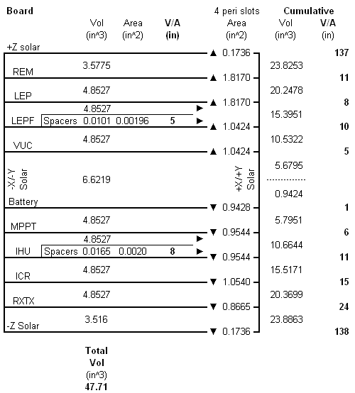

Figure 2 Schematic of Volumes and Areas

Figure 2 shows venting volumes and areas, with imbedded calculations for volume, area, and volume/area.

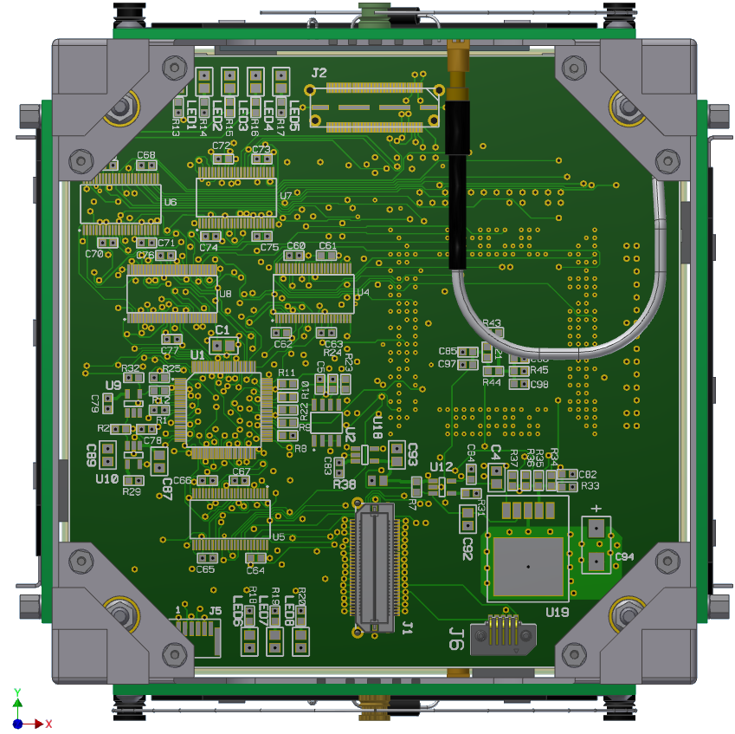

Figure 3 +Z end of PCB Stack, +Z and -Z Solar Panels removed

Figure 3 shows the PCB Stack inside the spacecraft by removing two Solar Panels.

The internal circuit boards vent around the four edges and four cropped corners. This is interrupted by occasional connectors, Delrin Mounts, magnet, etc. These additional items are accounted for.

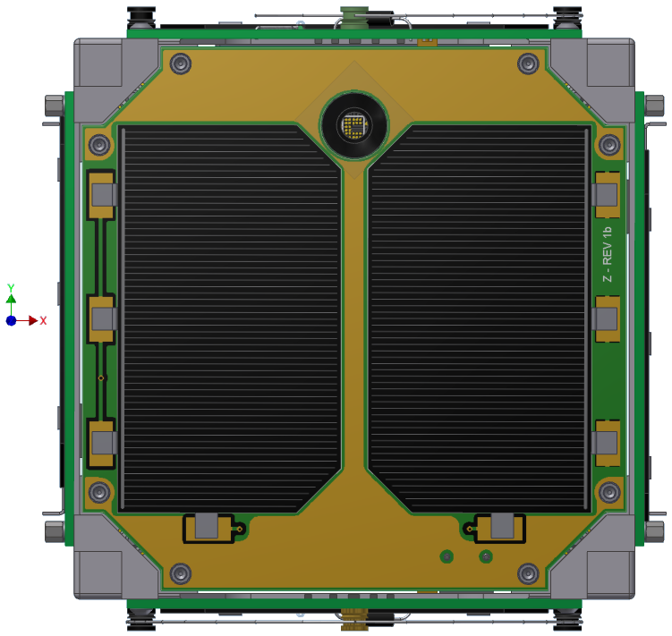

Figure 4 Venting around Z Solar Panel edges

Figure 4 highlights in red the four venting areas around the edges of the Z Solar Panel. Identical areas are present around the edges of the +Z and –Z Solar Panel.

Starting from a partial Battery volume (and upper 50% of RadFxSat-2 volume) towards the +Z Solar Panel (exterior):

1. Portion of Battery volume venting around VUC perimeter

Volume = ~86% (vents up) of 6.62 in3 (battery volume removed) = 5.68 in3

Area = 1.04 in2 total around 4 edges, 2 corner crops, and 2 Delrin Mounts

Volume/Area = 5 in

1. VUC volume venting around LEPF perimeter

Volume = 4.85 in3

Cumulative Volume = 5.68 + 4.85 = 10.53 in3

Area = 1.04 in2 total around 4 edges, 2 corner crops, and 2 Delrin Mounts

Volume/Area = 10 in

1. Spacers volume venting above LEPF

Volume = 0.010 in3

Area = 0.002 in2 one hole (conservative since actually two)

Volume/Area = 5 in

1. LEPF volume venting around LEP

Volume = 4.85 in3

Cumulative Volume = 10.53 + 0.01 + 4.85 = 15.40 in3

Area = 1.825 in2 total around 4 edges, 4 corner crops, and around camera cutout

Volume/Area = 8 in

1. LEP volume venting around REM

Volume = 4.85 in3

Cumulative Volume = 15.40 + 4.85 = 20.25 in3

Area = 1.82 in2 total around 4 edges, 4 corner crops, and around camera cutout

Volume/Area = 11 in

1. REM volume venting around +Z Solar Panel

Volume = 3.58 in3

Cumulative Volume = 20.31 + 3.58 = 23.83 in3

Area = 0.17 in2 total around 4 edges

Volume/Area = 137 in

Starting again from a partial Battery volume (and lower 50% of Fox-1 volume) towards the –Z Solar Panel (exterior):

1. Battery volume venting around Battery perimeter

Volume = ~14% (vents down) of 6.62 in3 (battery volume removed) = 0.94 in3

Area = 0.94 in2 total around 4 edges, and 3 Delrin Mounts

Volume/Area = 1 in

1. MPPT volume around MPPT perimeter

Volume = 4.85 in3

Cumulative Volume = 0.94 + 4.85 = 5.80 in3

Area = 0.95 in2 total around 4 edges, 2 corner crops, and 1 Delrin Mount

Volume/Area = 6 in

1. Spacers volume venting above IHU

Volume = 0.017 in3

Area = 0.002 in2 one hole (conservative since actually three)

Volume/Area = 8 in

1. IHU volume around IHU perimeter

Volume = 4.85 in3

Cumulative Volume = 5.80 + 4.85 = 10.66 in3

Area = 0.95 in2 total around 4 edges, 2 corner crops, and 1 Delrin Mount

Volume/Area = 11 in

1. ICR volume around ICR perimeter

Volume = 4.85 in3

Cumulative Volume = 10.66 + 4.85 = 15.52 in3

Area = 1.05 in2 total around 4 edges, and 4 corner crops

Volume/Area = 15 in

1. RX/TX volume around RX/TX perimeter

Volume = 4.85 in3

Cumulative Volume = 15.52 + 4.85 = 20.37 in3

Area = 0.87 in2 total around 4 edges, and 2 corner crops

Volume/Area = 24 in

1. Below RX/TX volume around –Z Solar Panel perimeter

Volume = 3.52 in3

Cumulative Volume = 20.37 +3.52 = 23.89 in3

Area = 0.17 in2 total around 4 edges

Volume/Area = 138 in

In the preceding calculations, the volume of RadFxSat-2 splits equally and vents in +Z and –Z. In the unrealistic failure mode of all four –Z or all four +Z slots blocked/ignored (which is also equivalent to Factor of Safety = 2), then venting through the remaining four slots still results in a volume/Area of only 276 in.

It is assumed that LSP-REQ-317.01B § 6.2.13 <2000 inches was derived to envelope all potential CubeSat launch opportunities, including that of NASA VCLS ELaNa XX, ≤ 0.4 psi/sec (dP/dt).

However lacking this explicit statement, a similarity can be drawn using

Spacecraft Compartment Venting, by John J Scialdone,

<https://ntrs.nasa.gov/archive/nasa/casi.ntrs.nasa.gov/19980236692.pdf>

There, a Volume/Area venting ratio of 2000 inch concurrent with a dP/dt depressurization rate of 0.50 psi/sec., yields a Delta P of approximately 2 psi.

Venting of Space-Shuttle Payloads, AIAA-1983-2600, by Mironer and Regan, indicates that typical electronic enclosures are capable of 2.5 psi, and this results in allowing as much as 1 ft ³ per 0.05 inch diameter hole. This V/A ratio is absurdly higher than the 2,000 in imposed by LSP-REQ-317.01B.

1. **Summary**

LSP-REQ-317.01B § 6.2.13

RadFxSat-2 is designed to accommodate ascent venting per Ventable Volume/Area < 2000 inches in accordance with accepted standards such as JPL D-26086, *Revision D, Environmental Requirements Document (ERD)*.

L1-VCLS-ICD

It is assumed that LSP-REQ-317.01B § 6.2.13 <2000 inches was derived to envelope all potential CubeSat launch opportunities, including that of NASA VCLS ELaNa XX, ≤ 0.4 psi/sec (dP/dt).

However, lacking that specific statement, similarity was drawn between 0.4 psi/sec and V/A=2000 inches to indicate that LSP-REQ-317.01B § 6.2.13 is more constraining.

1. **Compliance Certification**

I certify that RadFxSat-2 is in compliance with the venting requirements.

Sincerely,



Gerald Buxton

AMSAT Vice President of Engineering

AMSAT, the Radio Amateur Satellite Corp.

817-573-2465